**Project Design Phase-II**

**Data Flow Diagram & User Stories**

|  |  |
| --- | --- |
| Date | 16 June 2025 |
| Team ID | LTVIP2025TMID58401 |
| Project Name | ShopSmart - eCommerce Grocery Web app |
| Maximum Marks | 4 Marks |

**Data Flow Diagrams:**

A Data Flow Diagram (DFD) is a traditional visual representation of the information flows within a system. A neat and clear DFD can depict the right amount of the system requirement graphically. It shows how data enters and leaves the system, what changes the information, and where data is stored.

**Example:** [**(Simplified)**](https://developer.ibm.com/patterns/visualize-unstructured-text/)

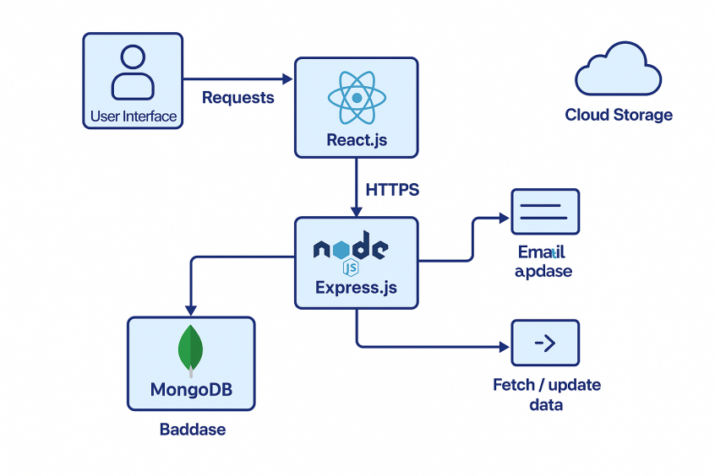

**User Stories**

Use the below template to list all the user stories for the product.

| **User Type** | **Functional Requirement (Epic)** | **User Story Number** | **User Story / Task** | **Acceptance criteria** | **Priority** | **Release** |
| --- | --- | --- | --- | --- | --- | --- |
| Customer (Mobile user) | Registration | USN-1 | As a user, I can register for the application by entering my email, password, and confirming my password. | I can access my account / dashboard | High | Sprint-1 |
|  |  | USN-2 | As a user, I will receive a confirmation email once I have registered for the application | I can receive confirmation email & click confirm | High | Sprint-1 |
|  |  | USN-3 | As a user, I can register for the application through Facebook | I can register & access the dashboard with Facebook Login | Low | Sprint-2 |
|  |  | USN-4 | As a user, I can register for the application through Gmail | I can register & access the dashboard with Gmail | Medium | Sprint-1 |
| Login |  | USN-5 | As a user, I can log into the application by entering email & password | I can successfully log in and view the dashboard | High | Sprint-1 |
| Dashboard |  | USN-6 | As a user, I can view featured products and categories on the dashboard | Products and categories are displayed properly | High | Sprint-1 |
| Cart & Wishlist |  | USN-7 | As a user, I can add or remove items from my cart and wishlist | Items are correctly added/removed in real time | High | Sprint-2 |
| Checkout |  | USN-8 | As a user, I can view my order summary and confirm my purchase | Order is created and confirmation is displayed | High | Sprint-2 |
| Customer (Web user) | Registration & Login | USN-9 | As a web user, I can register and log in using email or social logins | I can access my account/dashboard | High | Sprint-1 |
|  | Browse Products | USN-10 | As a web user, I can browse and search for products | Products list loads and filters work correctly | High | Sprint-1 |
| Customer Care Executive | View User Queries | USN-11 | As a customer care executive, I can view and respond to customer queries | I can see a list of queries and send replies | Medium | Sprint-2 |
| Administrator | Product Management | USN-12 | As an admin, I can add, edit, and delete product listings | Product changes are reflected in the product catalog | High | Sprint-2 |